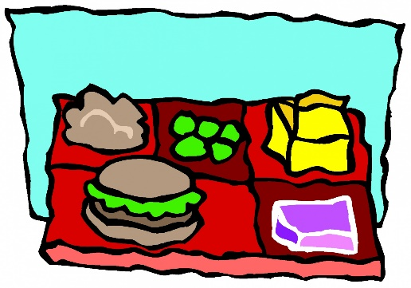
FREE LUNCH!!
ALL KIDS eat FREE through Decmber 31st at school!!!
The USDA has approved free breakfast and lunch for ALL students effective September 1st-December 31st. ****Charges still apply to Ala Carte items and extras. Contact the office with any questions. 970-265-2022
Lunch Ladies,
Stephanie and Samantha

